# FB Ad Secrets

Dear Business Owner,

I hazard a guess you run a business of some kind, but I know two things are for sure...

**That you want MORE leads and you want MORE sales.**

I mean, who doesn't, right?

It does not matter whether you offer training and consulting, or peddle your own products in an e-commerce store, or sell your own information products and online courses, run a restaurant, or operate a car workshop...

The good news is that whatever it is you are selling right now, there is a high chance most if not all your Customers are hanging out in the same place today, and that's Facebook. How convenient!

If you want to know how to generate more leads and close more sales using Facebook but have absolutely no clue how it works until now, then the answers are staring back at you.

You will discover...

* **The No. 1 Rookie Mistake most Business Owners, your friends and family do** when they try to sell on Facebook for the first time (and why you need to stop this sh*t right now before you waste any more time and money)
* **My blueprint to using Facebook to generate qualified (yet inexpensive) leads** that go on to become your Customers or Clients
* **How to build your brand passively**
* **How to close more sales on sheer autopilot in the next 14 to 30 days for dirt cheap** (I'm talking about cents and dollars here)
* **How to trounce your Competitors next door** (as of this time of writing, there is a high chance they are clueless about Facebook themselves!)
* Our survey on local Businesses in our country that reveals openings and advantages for YOU and your business
* **And more...** I've deliberately made this book short so you can read it fast.

Again, it does not matter the type of business you are doing right now. As long as you have something to sell, it's not illegal B.S. and preferably it's not in a highly regulated industry, then you too can make this work :)

Alright, let us dive into it right now...

## How NOT To Use Facebook For Your Business

At the top right menu in your Facebook account, click on "Create Page" and within the next several seconds, you have created a Fan Page for your Business.

You add in some basic info and slap up some starting content, so it does not look too shabby.

Then you ask your family, close friends, and relatives to like your newly created Fan Page. They obliged.

You have also created new Posts promoting your Products or Services right away. However, you noticed from the stats... **no one is really viewing it!**

Even if you are a well-known person or have a lot of followers and likes on your Page, even at a minimal fraction this is rather pathetic seeing only less than 10 people viewed your Post out of, what? 1,000 likes?

You realize Facebook is a pay-to-play game. If you want to reach more people, you have got to be ready to pay up – which you are.

You notice the "Boost Post" button and you placed in a few dollars to get the ball rolling, with the hope of more viewers on your Posts.

.. And they do alright, with the exception that you are merely paying Facebook to reach the rest of the people who have been following your Page! Some Facebook marketers have a nickname for the "Boost Post" button... we call it "Donate To Facebook".

And you know, there's a saying that your friends and family members aren't your ideal Customers (I believe that)

Now you have no clue what to do next. Your Fan Page has only a few miserable likes and you are some dollars short - it is barely inspiring to continue the Fan Page. So, it fades into obscurity. You have given up.

......

Okay, does this sound anything like what you have done and/or are doing right now? **Then STOP!**

This is exactly what many business owners out there are doing and losing money without realizing and knowing what and why.

It is not your fault - and it's not theirs either - it's just that while Facebook is a great marketing channel, there's more to it than getting a bunch of likes and Boosting Posts.

## The REAL Purpose Of Facebook Marketing...

... Is for reaching out to people who can and will become your Customers. This usually means reaching out to the people whom you would not be able find on your own.

Isn't that the whole point? If all you want to do is to reach your own circle of friends and family members, you could just pick up the phone and call them directly. Or heck, just use your personal Facebook profile.

It makes little to no sense to pay Facebook to get your Posts seen by people that already like your Fan Page (usually your own friends and family members) unless you have

**(1)** accumulated a huge following, and

**(2)** you have a special reason to reach more of your own existing fan base

Other than that, look, if you are going to spend advertising dollars you might as well be spending them to reach people who have not heard of you yet.

Now of course, do not go selling and pitching right away (everyone HATES that!) If it is done incorrectly, you are going to have your Facebook Ad Account banned.

They are called "Cold Traffic" for a reason; these folks have not heard of you before. So 'talk' to them the same way you talk to anyone that you meet for the first time - keep it casual and build your brand awareness.

Asking for the sale becomes a lot easier later.

## Why Facebook Marketing

Because consider the following...

* **There are over 2.7 Billion active users monthly on Facebook** (that is 1/3rd of the world population!)
* Facebook and by extension Instagram (that was bought over by FB) **combined are BIGGER than the next 10 channels combined** *[Source: DigitalMarketer.com]*
* And it's the **world's most popular** social media platform *[Source: Alexa]*

**CRAZY COOL, HUH?!**

Bill Gates once said his famous quote…

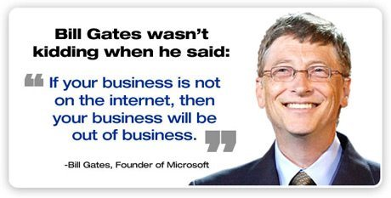

Today, if your Business is not on Facebook, soon you will be out of business.

But you and I are in luck to be living in very exciting times. There's never been a better time to reach more Customers and Clients inexpensively and conveniently.

We're fast putting behind us the days where newspaper and billboards were the only ways to get the word out about your product or service.

*(Even newspaper companies realize this and are now on Facebook, they're so desperate for views they're paying massively in sponsored advertising to get their articles out and even stoop low to clickbait-y headlines and controversial news just to get our attention!)*

**In short: today most if not all your Customers are hanging out on the same place** i.e. Facebook and by extension, Instagram. If your business is not on Facebook or you're not doing much to build a presence here, why not? If not now, then when? If not you, then who? Your competitors? Nooo wayyyyy...

## How I Got Into Facebook Marketing

You would think that for someone who has been running an Internet Business for years would naturally catch on fast. It is embarrassing to say despite that, I only caught on much later. I suppose it happens when we get too comfortable doing what we always do – in short complacent.

I recognized the importance of being on Facebook and marketing it there. While I write my own ad creatives, I hired someone else to run my ads for live seminars.

Oh man, what a frustrating experience that was.

**To put a long story short:** I moved from one social media agency or "expert" to another, spent **thousands of dollars (again, not Ringgits)** and instead of results, I received excuses.

My ad was not good enough, there is a big update on Facebook algorithm, people were not interested... the excuses goes on and on.

Do not get me wrong. I am not saying there are not any good social media agencies out there; there are... **however they are few and far in between.**

There are a lot of incompetent social media 'experts'; do not be surprised if they have read off a book or course somewhere and take a gamble on your budget - no skin off their backs.

If at all, you should be extra cautious about who you engage to handle your social media marketing work. Check on their credibility and results.

So out of sheer frustration and dissatisfaction, I decided to learn Facebook ads and Facebook marketing on my own.

I had subconsciously dodged it for 5 years but this time I was determined to see it through. **Besides, what is an Internet Marketer if he does not at least know how to market on social media today, right?**

Kid you not, when was the last time you studied something intensely that led to feeling unwell? That was precisely what happened to me, after a few months of struggling; trying to understand Facebook Ads and learning on my own.

Eventually, the results finally bore fruits.

## You Can't Withdraw "Likes" From The Bank...

Occasionally, I am challenged by trolls. "Your Fan Page has 3,000+ likes only! You call yourself an Internet Marketing expert??"

I agree, that's a very small number by today's standards. But you know what? Likes do not put food on the table or pay bills. Likes will not and cannot afford a lifestyle.

You know what pays for these? **Sales.**

Granted, you need to build a funnel and get people from Interested to Committed to Closed. But that's the bottom-line - the name of the game is Sales.

While everyone else is chasing the Likes counter, I am focused on generating consistent Sales.

Likes and Shares have their place as far as social proof goes (and trust me, it's easy to get them and get them dirt cheap) but if you want to be successful with Facebook Advertising, you have got to focus on SALES.

**All your efforts on Facebook should revolve around getting sales.**

So, is the number of Likes honestly important? My relatively low Like count on my Fan Page didn't stop me from getting Clients that pay me anywhere **from 4 figure all the way up to 6 figures** **(hmm... how much are those trolls making?)**

Or getting an average **4X Return On Ad Spent**, and sometimes higher (like the above example).

One of my American mentors has slightly over 25,000 Likes on his Fan Page. You'd think that for someone who's making **$10 Million a year**, he ought to have a higher Like count!

On the other hand, I can name you famous social media 'influencers' with 6 figure following on Facebook but little to show for income, and some of their Post Engagement has only 1 digit Likes.

Likes can be bought. Likes can be manipulated. **But in the end, who cares..**

## The 2 Things That Matter...

This goes out to everyone running a business of ANY industry.

Sure, some social proof helps, but this can be worked around easily. Heck, this can also be 'faked' easily and cheaply if you are determined. (The "Boost Post" purpose)

With that being said, only 2 things are important to your business:

**1. Constant flow of targeted Leads**

**2. Converting Leads into Sales**

## Facebook Ads Blueprint: How To Maximize The Use Of Facebook To Generate Leads And Customers To Your Business

What I am about to share with you will help you save thousands of Ringgits on home study courses and live workshop fees. This took me a long time to discover and improve through trials and errors, even up to this day I continue to improve and innovate.

At the start of this, I have mentioned to you what most Business Owners with ZERO understanding on Facebook marketing do, which is merely:

1. Create a Fan Page (who can't do that?)
2. Get friends and family to like the Page (again, who can't do that?)
3. Slap up some Posts and Content (easy peasy)
4. Some wonder what to do next (uh oh, stuck...)
5. Some clicks on "Boost Post" (as you already learned by now, this is also known as "Donate To Facebook" button)
6. No results... then give up

Moving up the rung of the ladder, you have some slight savvy Business owners and marketers who uses Facebook Ads with some results.

|  |
| --- |
| **First, you MUST, MUST, MUST have a Facebook Business Manager Account!**  No exceptions. No debate. Do NOT attempt to use your Personal FB Ad Account. Just, trust me on that.  Creating a Business Account is simple. Just follow this:  <https://www.facebook.com/business/help/1710077379203657>  After creating it, what you're about to see next will appear overwhelming, but personally even I don't use all these features; I stick to the usual few.  Besides that, the Ads Manager and other features like Audience and Pixels are identical to your Personal Ad Account. The difference is now you have a variety of useful features. |

This is what their model looks like:

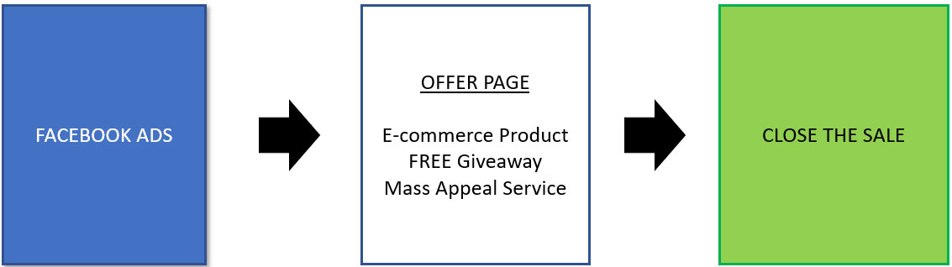

This is a direct Facebook Ads to Offer model. For simple, straight forward Businesses like E-commerce; this still works like a charm.

You place an image or video ad, send people straight to the Product Page and buy. Simple as that.

  
*An example of a Facebook ad for one of the products on my E-commerce store.*

E-Commerce marketers make their profits selling in quantities and bundled Packages. The smart ones use Email marketing too, where they get their Customer and non-buyer emails onto their list, so they can continue mailing them about their offers.

Ingenious, because from this point on **it does not cost anything to email your list** of visitors other than the monthly cost of using the autoresponder!

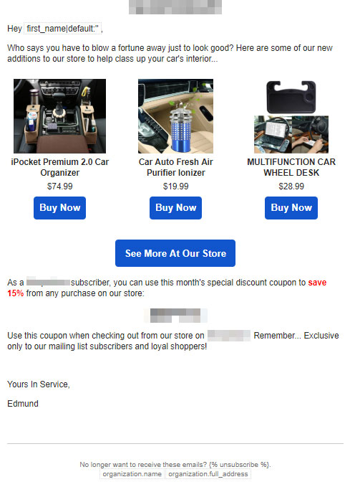 *An example of an email I send out to my list. Log in, write up for a few minutes, then click SEND or SCHEDULE. Boom, everyone gets it!*

**LESSON**: Whatever traffic you get online - even from Facebook - always get your Visitors details so you can follow up with them.

If you are offering a straight-forward product or service like E-Commerce, car workshop, restaurant, etc. and prices are not really that high, this model is pretty much all you need.

## What If You're Selling High Priced Offers Like Coaching, Consulting... or Properties Even?

I know they are different but one thing they have in common is that they fall under High and Ultra High Ticket, to the tune of **4 to 6 (sometimes 7 figure) $!**

It is obvious - you do not want to scare people away by naming exorbitant prices upfront. And I don't recommend that because your prospects will be fixated on the price and not the value.

In fact, many will feel they do not have that serious problem to warrant spending their hard-earned money with you in the first place. Educating your prospect is more paramount here compared to the first Facebook Marketing model I mentioned earlier.

My model goes like this:

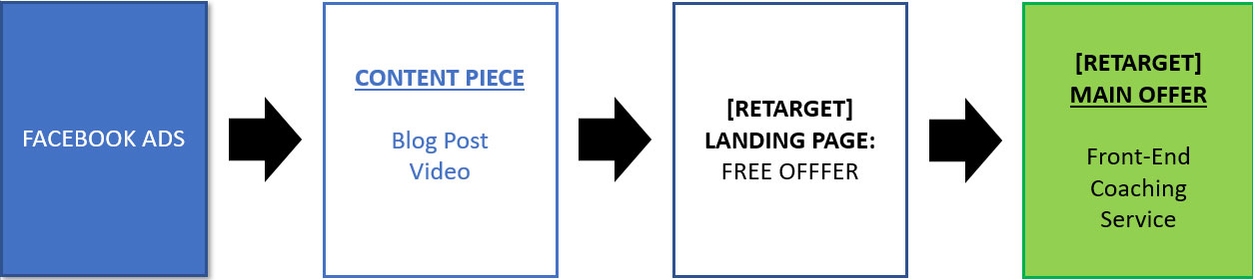

Let me explain…

I create a **Traffic**, **Pay Per Engagement** or **Conversions** (most preferred) Campaign on Facebook with the purpose of getting visitors to click on the link and the Blog Post on my website.

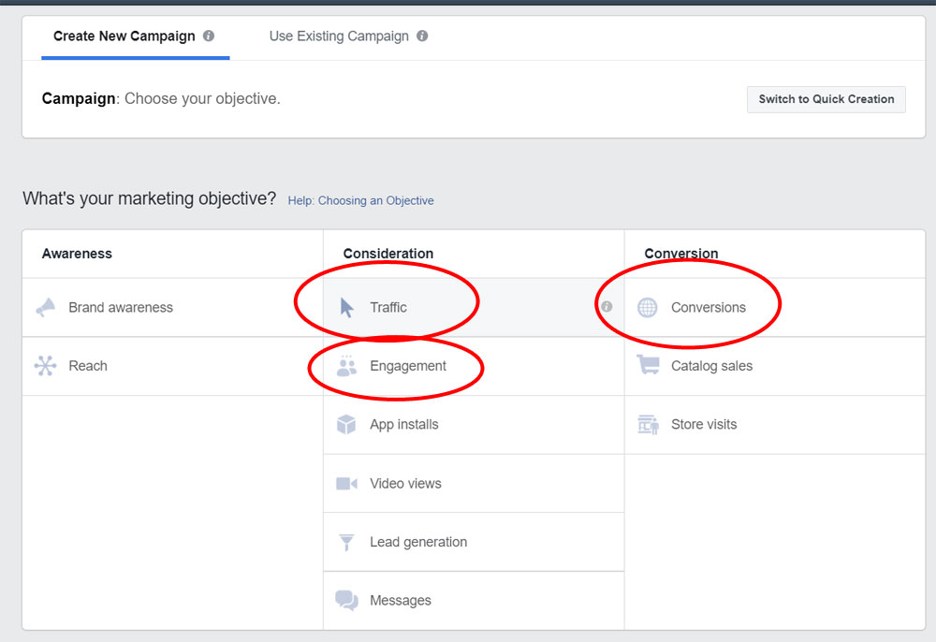

The next Step (Ad Sets), I choose my targeting – usually I test several Ad Sets with each Ad Set targeting one **Detailed Interest** or **Custom Audience**.

And they all get directed to the same Ad or Post…

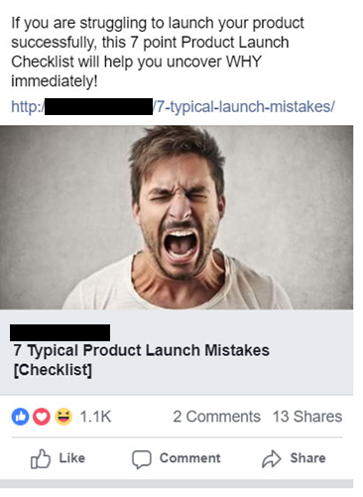

There is nothing on sale here when visitors visit my Blog Post article, however my Call to Action is to get them to sign up onto my mailing list.

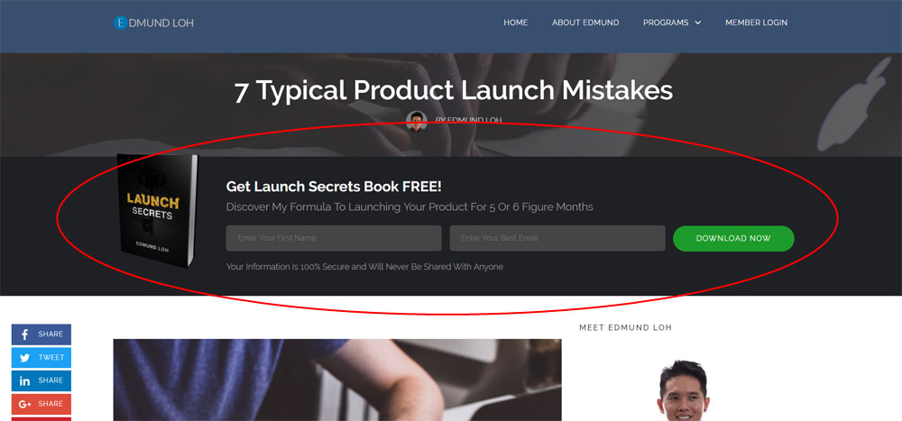

I incentivize them with a **FREE Gift**, usually a short Report or a video. The purpose of this giveaway is to solve an immediate problem.

Now that the visitor is subscribed to my mailing list, I can be almost certain to say that he/she has been to my site and had probably engaged my Post i.e. like, comment or share.

## Turning Stone Cold Strangers Into Warm Prospects...

So, the first layer of ice has been broken by now. Prior to this, my visitors had no idea who I am.

**No straight up pitch or hard sell them**. If that is done; not only will you not achieve any sales, Facebook does not like that either. If your Relevance Score is low, Facebook shows your ad to less people and charges you more. I am very sure you would not want that to happen – no one does.

So, what does Facebook prefer? **Quality content!** Therefore, give them just that.

## Retargeting Magic: Saving Lost Traffic And Sales

This is where Facebook excels the best. Even if you have not heard of Retargeting, you have seen it in action.

Have you ever been to some websites such as booking a hotel stay and when you move back to Facebook you start seeing ads like that?? Yup, that is retargeting at work.

Quite simply: you have your ad follow visitors that had been on your website or engaged with your content, and your ad follows them on Facebook!

*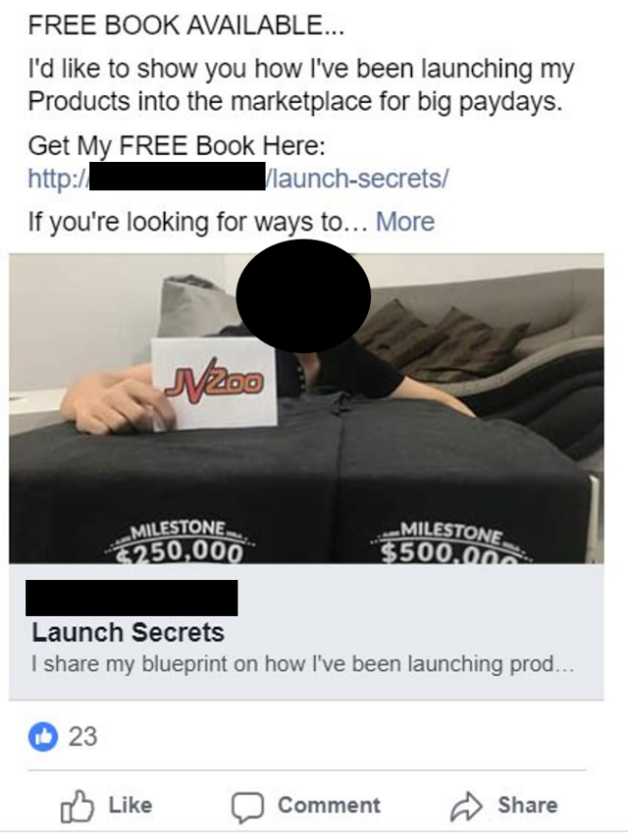  
When people visit my Blog Post and read Articles, Facebook Pixel on my site tracks them. I now show them a new ad: this one. The intention now is to get their email address and get them onto my mailing list.*

**And this is cool... Facebook allows you to retarget your audience for up to 180 days from first contact!**

Personally, I do not have my ads follow my prospects all the way... some are as short as 7 days, and the rest up to 30 days.

My rationale is that if even after 30 days they are not interested on taking any action, I rather not waste my money advertising to them repeatedly. Besides, this would not bode well for my overall FB Ad Relevance Score too.

However, if you are a marketer of some kind then you ought to know how important following up is. Most people don't act right away, for whatever reason...

Maybe they're not convinced yet.

Maybe they think they don't need it now.

Maybe at that point they could not afford it.

Maybe it was not convenient when they were browsing - driving or walking.

That is why Retargeting is effective. **You can close more sales in the coming days and do this on sheer autopilot** - just set up the ad, turn it on and let it run!

Plus, you know what? It's dirt cheap!

Check this out: I ran retargeting campaigns for my client for their online product launch, and here is how many sales they saved or otherwise could have lost...

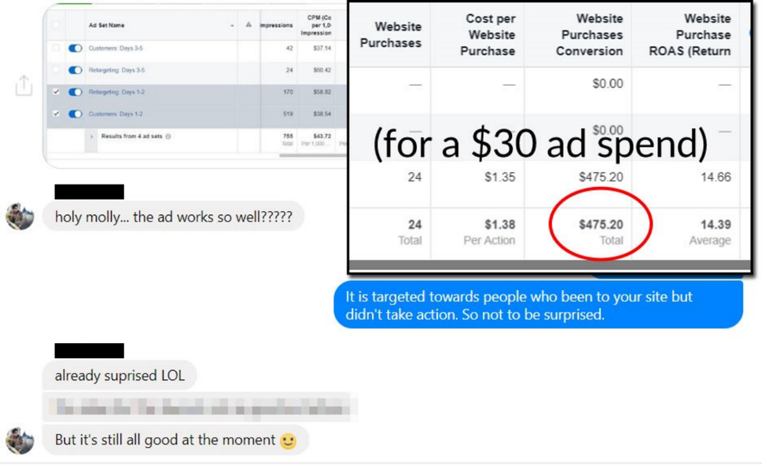

**That is more than 10 times the returns, and they saved slightly less than $500 in sales which otherwise could have been lost…**

**Think what this means to your Business…**

Before Facebook, the only way you can follow up with your Prospects online is through email marketing.

Today, you have email marketing + Facebook and possibly other ways to continuously reach your Prospects!

## Turning Warm Leads Into Hot Buyers...

Once your Prospect knows you and what you're all about, it's time to let him know what you can do to solve his/her problem.

Again, using the same example...

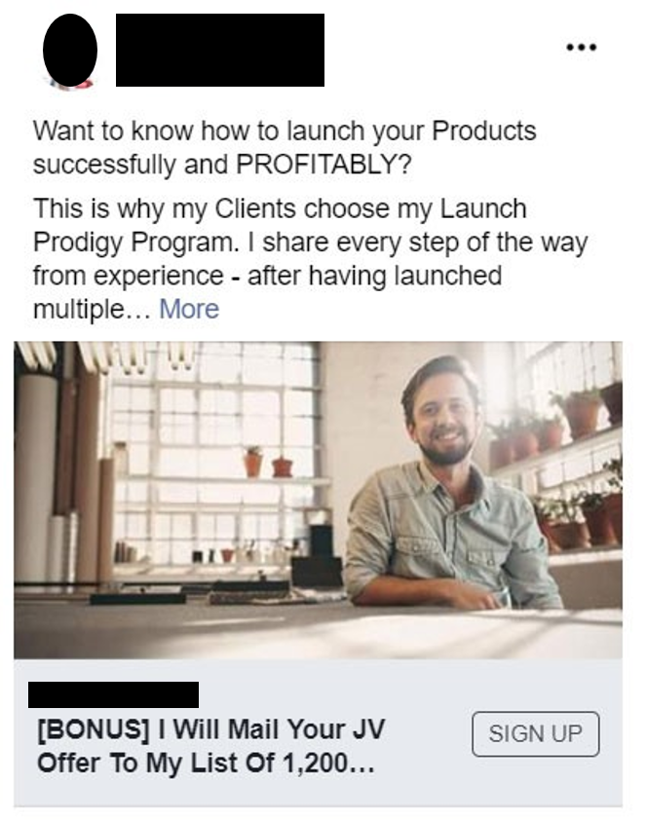

You can see I'm offering an Online Training Course, and if he wants in he has to pay for admission. Is it easier to sell at this stage? Absolutely! He now sees the value and had I done this any earlier, he would've been focused on the price only!

While this example is in the Information Business, **the same applies to Coaching and Consulting.**

**Can you do the same? For sure!** I've used the same exact model to sign up Clients through my Strategy Sessions and earn back **4X to 5X** the Return On Ad Spent!

This is made possible because the Clients I talk to are qualified, filtered and are rarely random applicants - it took several actions for them to get on a call with me, which means they are convinced and they've sold themselves halfway through already...

## Taking It To The Next Level...

I trust Facebook Advertising is no longer a mystery to you by now, compared to before you picked this up!

There is a high chance even your competitors aren't doing it right and there's no better time than now to waltz past them and DOMINATE your niche or field or area.

**Be warned though: this might change in a few years and eventually, they will catch on (if they haven't yet)**

However, if you do your Facebook funnel and campaign right, you will be bringing back more revenue than how much you pay for in advertising. **If for every $1 you spend, you retrieve $2, $4 or $10 even... how much will you be willing to invest?**

If you can keep getting a continuous stream of leads and Customers, **how long will you keep the doors open?**

Hope this enlightens you as it did for me when I discovered this epiphany.

Here’s To Your Marketing Success!